Project Planning Phase
Project Planning Template (Product Backlog, Sprint Planning, Stories, Story points)

Date | 25 February 2026
Team ID | LTVIP2026TMIDS81684
Project Name | Calculating Family Expenses using ServiceNow
Maximum Marks | 5 Marks

Product Backlog, Sprint Schedule, and Estimation (4 Marks)
Use the below template to create product backlog and sprint schedule
Sprint | Functional Requirement (Epic) | User Story Number | User Story / Task | Story Points | Priority | Team Members
Sprint-1 | Expense Management | USN-1 | As a user, I can add daily expenses with date, amount, and details | 3 | High | Team
Sprint-1 | Expense Management | USN-2 | As a user, I can view all expenses in the system | 2 | High | Team
Sprint-2 | Expense Tracking | USN-3 | As a user, I can calculate total expenses automatically | 3 | High | Team
Sprint-2 | Expense Tracking | USN-4 | As a user, I can view expenses grouped by date | 2 | Medium | Team
Sprint-3 | Reporting | USN-5 | As a user, I can check expense summary and reports | 3 | Medium | Team
Sprint-3 | Admin Control | USN-6 | As an admin, I can manage expense records | 2 | High | Team

Project Tracker, Velocity & Burndown Chart: (4 Marks)
Sprint | Total Story Points | Duration | Sprint Start Date | Sprint End Date (Planned) | Story Points Completed | Sprint Release Date
Sprint-1 | 10 | 5 Days | 01 Feb 2026 | 05 Feb 2026 | 10 | 05 Feb 2026
Sprint-2 | 10 | 5 Days | 06 Feb 2026 | 10 Feb 2026 | 10 | 10 Feb 2026
Sprint-3 | 10 | 5 Days | 11 Feb 2026 | 15 Feb 2026 | 10 | 15 Feb 2026
Sprint-4 | 10 | 5 Days | 16 Feb 2026 | 20 Feb 2026 | 10 | 20 Feb 2026

Velocity:
The team followed a 5-day sprint duration for each iteration. The total story points completed per sprint were approximately 10. Therefore, the average velocity of the team is calculated as:
Velocity = Total Story Points / Sprint Duration = 10 / 5 = 2 points per day
This velocity helped the team estimate workload and plan future sprints efficiently.

Burndown Chart:
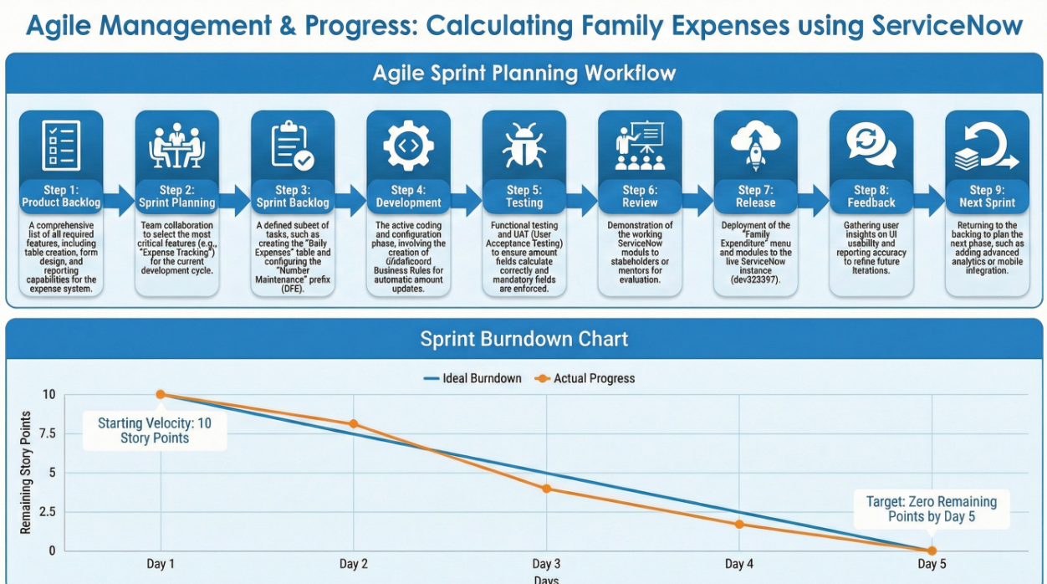

A burndown chart is used to track the progress of work completed versus the remaining work in each sprint. In this project, the burndown chart helped monitor the completion of user stories related to expense entry, tracking, reporting, and administration features. The chart ensured that the development stayed on schedule and allowed early identification of delays.
https://www.visual-paradigm.com/scrum/scrum-burndown-chart/
https://www.atlassian.com/agile/tutorials/burndown-charts

Reference:
https://www.atlassian.com/agile/project-management
https://www.atlassian.com/agile/tutorials/how-to-do-scrum-with-jira-software
https://www.atlassian.com/agile/tutorials/epics
https://www.atlassian.com/agile/tutorials/sprints
https://www.atlassian.com/agile/project-management/estimation
https://www.atlassian.com/agile/tutorials/burndown-charts

